Highland County GIS site user guide
- Go to highlandcountyeng.org
- 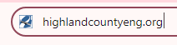
- Click Departments tab 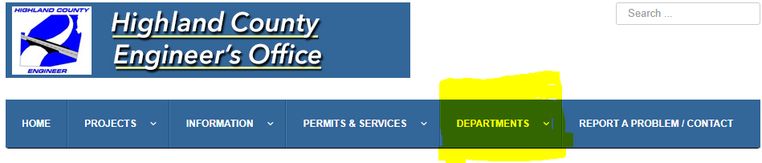
- Click Tax Map tab
- 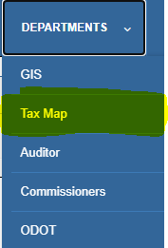
- Go to the link beside GIS mapping also available: Highland County, Ohio GIS 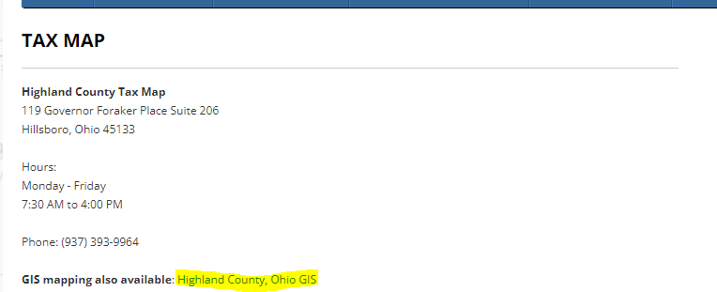
- You are now on the website.
- There will be options at the top of the page. Go to the SEARCH button
& click on it. It will pull up different options to search by, Owner’s name, Parcel No., Subdivision Name, Road Name or Address.
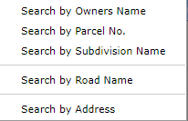

HINT: If you choose to search by:
- Owner’s name you will have to know exactly how the name is listed on the property or you can search by last name only. It will give you all the property owners in Highland County with that last name listed alphabetically by first name.
- Parcel number use ONLY NUMBERS-no dashes or periods.
- By Subdivision, if you are not sure of the exact name search by the first name of the subdivision.
- Road-You can type the road name.
- Address-Only list the number portion of the address. It will bring up a list of all the same addresses with that number.
- The search box will appear at the bottom of the page.

- After you have entered what you are searching for results will appear at the bottom of the page & will list the owner’s information, acreage or lot #, address, last transfer Book or Volume & page number. The next column is DETAIL. If you click on detail, it will show the most recent transfer information & information on the parcel. If there is a survey on file for the property, there will be an option in the middle (SURVEYS ON FILE) that you can click the link to access surveys.
- The ZOOM column will take you to the parcel itself. You can hover over the parcel & a box will pop up with more options...
- Click to view report
- Click to view Surveys
- Click to Auditor site
- Click to view property card (This will be the original property card that was scanned into the site January 2023. The updates to the property card after that date will now be found under the detail button.)
**You may use the arrows to enlarge the results area (located at the bottom right of page). **
The legend will have more options that you can checkmark for a more detailed search. If you have any questions, please contact us @ 937-393-9964.

